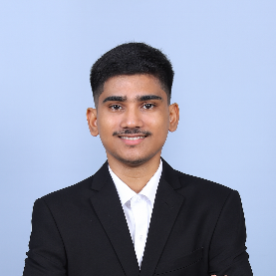
Ovi Saha

Contact No: 01838903857

E-mail: ovisaha441@gmail.com

CAREER OBJECTIVE

Organized and responsible professional seeking a corporate position to support operations, improve efficiency, and contribute to a productive and collaborative work environment.

EDUCATIONAL QUALIFICATION
Bachelor of Science (B.Sc)
University : Feni Unuversity
Department : Computer Science & Engineering
Passing Year : 2022
Result : CGPA 3.88 Out of 4.00

Higher Secondary School Certificate (H.S.C)
College : Chowmuhani Govt. S.A. College
Group : Science
Board : Comilla
Passing Year : 2016
Result : CGPA 4.42 Out of 5.00
Secondary School Certificate (S.S.C)
School : Begumgonj Govt. Pilot High School
Group : Science
Board : Comilla
Passing Year : 2014
Result : GPA 4.38 Out of 5.00

PERSONAL INFORMATION

Full name : Ovi Saha
Father’s Name : Ashis Kumar Saha
Mother’s Name : Alo Saha
Date of Birth : 10-05-1998
Marital Status : Unmarried
Religion : Hinduism
Present Address : College road, Chowmuhani, Noakhali
Permanent Address : College road, Chowmuhani, Noakhali

LANGUAGE PROFICIENCY

Language | Reading | Writing | Listening | Speaking
Bengali | Excellent | Excellent | Excellent | Excellent
English | Excellent | Good | Good | Moderate

Personal Experience

Private Tutor
Self-employed |2019- Present]
- Provided one-on-one and group tutoring for students from class [6–10].
- Taught subjects such as [Math, Science & English].
- Developed personalized lesson plans to improve student understanding and performance.
- Helped weak students gain confidence and achieve higher grades.
- Communicated regularly with parents regarding student progress.

Skills

- MS Word, Excel & PowerPoint
- Report & Presentation Preparation
- Data Entry & Basic Analysis
- Professional Communication
- Time Management & Teamwork

EXTRA CURRICULAR ACTIVITIES

Photography, Poem Recitation, Sports

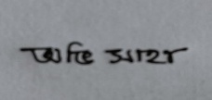

Signature

